Why different planets need different orbital velocities
Author: Prarthana Majhi
Affiliation: Undergraduate Student, Aerospace Engineering
Keywords: Orbital Velocity, Escape Velocity, Satellite Motion, Earth Orbit
Introduction
Orbital motion is a fundamental concept in celestial mechanics. All planets orbit around the sun but everyone has different orbital velocity dues there difference in mass and distance. This research paper explains why different planets need different orbital velocity to maintain the orbits. We use the newtons law of gravitation, centripetal force and orbital mechanics for the explanation. Also, this paper contains simple python based computational approach to compare 2 planets for the orbital velocities and sizes. This tell how python is practical tool that can be used in aerospace studies.

Keywords
Orbital velocity, gravitation, centripetal force, python

Introduction
From kepler’s law to newton’s law we have continuously evolved our understanding of rotatory motion of planets around the sun. the perfection motion of planets around the sun has always fascinated scientist for centuries. One questions which revolves around is why planets near the sun orbits faster than rest even whit different mass.
Things the paper is going to focus on:
- The reason for different orbital velocities of planets
- Creating a mathematical relation between orbital velocities of planets
- Showing how python can be used in aerospace technologies for calculations

Theories
- Gravitational force
According to newton, the gravitational force between two masses is given by:
F= G (M*M)/R^2
Where:
G= gravitational constant
M= masses of the planet
R= distance between the planet and the sun
This tells us that, according to newtons gravitational law the force is inversely proportional to the square distance between the planet and the sun.
As the distance increases the gravitational force decreases. This tells that planet away from the sun experience weaker gravitational force.

- Centripetal force and orbital motion
Centripetal force is important to keep the planet orbiting.
The force is given as:
F= MV^2/R
M= mass of the planet
V= orbital velocity of the planet
R= distance between the planet and the sun
Now by equating both the equations:
G (M*M)/R^2 = MV^2/R
V = (GM/R)^1/2
Thereforth, we get that the orbital velocity is inversely proportional to the root of the distance between the planet the sun.
The greater the distance the lesser the orbital velocity.

Conclusion
1 Effect of Distance from the Sun
- Planets closer to the Sun have smaller orbital radii.
- A smaller R results in a larger orbital velocity.
- Hence, Mercury moves much faster than Neptune.
2 Stability of Orbit
If a planet’s velocity is:
- Too low = it will fall toward the Sun.
- Too high = it will escape the Sun’s gravitational pull.

Use of python
CODE:
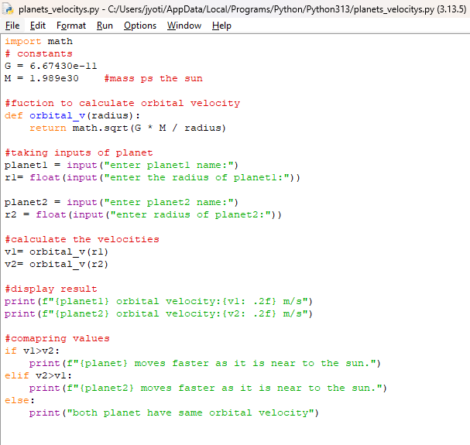
OUTPUT:
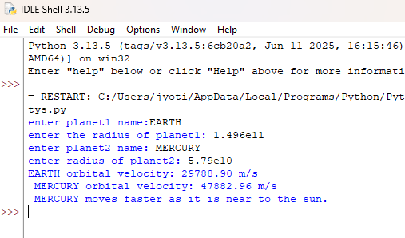
Explaination
- Imported math module to perform high level calculations like square root.
- Defined some constant like the gravitational constant and the mass is the sun which will be same through out the code
- Created a function to calculate the orbital velocity once to create a reusable code.
- taking input from the user for which planet they want
- calling the function or calculating the values
- displaying the velocities
- comparing the velocities

Results and Discussion

The results obtained from the Python code confirm the theoretical prediction that planets closer to the Sun have higher orbital velocities. This computational verification strengthens the understanding of orbital mechanics and highlights the importance of programming in modern aerospace research.

Conclusion

Different planets require different orbital velocities because gravitational force varies with distance from the Sun. To maintain a stable orbit, each planet must move at a velocity precisely determined by its orbital radius. The Python-based comparison provides a simple yet powerful demonstration of this concept, bridging theoretical physics and practical computation.

Bibliography
- NASA Solar System Exploration Resources.
- Geeksforgreeks
- Wekipedia

